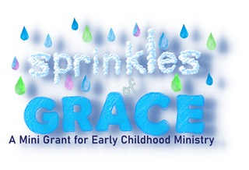

Sprinkles of Grace Mini Grant Application
“I will sprinkle clean water upon you” Ezekiel 36:25

Application

Grant Project Title:

Grant Project
In five to ten sentences, tell us about your project. Please highlight how your project is creative and innovative.

How will this project impact the young families of your congregation and/or community?

What was the process you used in determining this grant project?

How does your project meet the grand guidelines as listed in the overview?

Grant amount requested: _____________ (Maximum is $1000)
How will this grant money be used? (See budget sheet)

Sprinkles of Grace Mini Grant Budget
Please refer to the Mini Grant Guidelines for any information about this grant. Fill out the budget as closely as you can to help us better see what you are doing. Mini grants are for a maximum of $1,000.00.
Project Name:
Description of Items (purpose) : | Quantity | Cost of Item | Shipping Expense | Total Cost
Total Cost
Total :
Any matching funds from other sources such Thrivent grants
Total
Total requested from Sprinkles of Grace Grant:

