Announcing SD Faith in Public Life’s
Love Your Neighbor Micro-Grants
for congregations, and community and educational groups
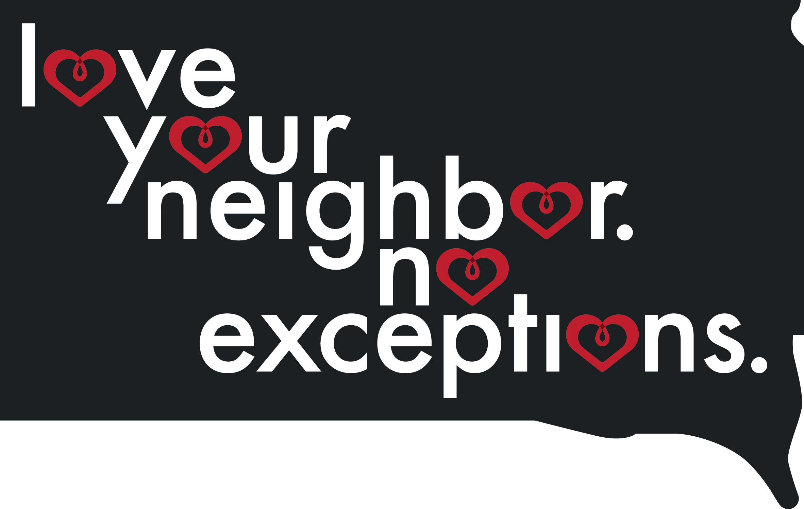

Join SD Faith in Public Life to encourage other South Dakotans in your community to stand together, be allies, and love their neighbor, no exceptions!

SD Faith in Public Life is excited to make funds available for congregations, ethnic support organizations, campus groups, community groups, and schools to create local visibility, education, or community service projects dedicated to tolerance, respect, mutual support and ally-ship. These grants of $100-$750 will build capacity across the state and empower people of good conscience to act in their own congregations, schools, and towns to support and show ally-ship with vulnerable community members.

Examples of potential projects might include:

- Hosting a potluck with members of a vulnerable group in your community to explore each other’s foods and build new relationships;
- Hosting a cultural appreciation event at a religious center or school, focused on food, music or a movie from another religion or culture;
- Creating a mural or poster campaign that supports inclusion, mutual respect and kindness at a church, school or college/university;
- Developing a Sunday School or adult education project – funds could be used to purchase curriculum, buy books for a discussion series, or to cover a speaker’s travel costs;
- Buying children or young adult books focused on refugees, immigration, LGBT families, Native Americans, Muslim or Jewish Americans, etc. for school or church libraries;
- Taking a group field trip to visit the SD Muslim Community Center, a Native American Center, or a refugee resettlement agency to learn more about a community and its beliefs or needs.

Applications for micro-grants will be accepted on a rolling basis from April 1 through May 31, 2017. Projects must be completed on or before October 31, 2017.

To apply, please fill out the following short form and email it to sdfaithinpubliclife@yahoo.com.
Or mail completed application to: PO Box 456 Freeman, SD 57029

“Micro-Grant Application

Due on a rolling basis from April 1-May 31, 2017

Organization Name:
Is your organization a: __________ Religious Congregation __________ Campus/School Group
__________ Civic Organization __________ Other (please describe ________________________)
Contact Person Name:
Contact Email:
Contact Phone Number:
Contact Mailing Address (for follow-up/reimbursement):

Please briefly describe your project and how it will help encourage South Dakotans to “Love Your Neighbor. No Exception.” (250 Words or less)

What vulnerable community will be affirmed by or partnered with during the course of your project? (Please mark all that apply.)

_____Resettled Refugee South Dakotans _____Recent Immigrant South Dakotans
_____Muslim South Dakotans _____Jewish South Dakotans
_____LGBT South Dakotans _____Native American South Dakotans
_____Other South Dakotans (please specify) _________________________________________

How much money do you need to make your project a reality? Please list a very simple budget here. [For example, for a Syrian refugee themed cultural movie night and food event at a church, you might list the following budget: DVD of documentary movie: $25, Printing costs for flyers and a newspaper ad to advertise movie night & discussion materials: $100, purchase of Syrian food from a local Syrian restaurant: $150, paper plates/napkins/cups: $50. Total budget: $325.]

Completed applications can be sent to sdfaithinpubliclife@yahoo.com or PO Box 456, Freeman, SD 57029. Applications will be reviewed on a rolling basis from April 1 through May 31, 2017. Projects must be completed by October 31, 2017.

