JOINING A ZOOM MEETING
Most people join the meeting on a computer. You may also download the Zoom phone or tablet app and join the meeting on a portable device. For audio-only, you may join by phone.

THREE OPTIONS TO JOIN:
1) Click on a link provided to you and you will be taken directly to the meeting,
(invitation link)
OR
2) Go to https://zoom.us/join.
Then type in the meeting number provided to you:
Meeting ID: (on invitation)
OR DIAL BY PHONE
3) From your phone, dial: (on meeting invitation), then follow the voice prompts to enter the Meeting ID above.
SOUND AND VIDEO:
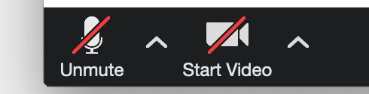
Hover over the Zoom window and these controls will appear in the lower left-hand corner of the screen.
• To turn your microphone on, click the “Unmute” button. We recommend having your microphone on “mute” all the time unless you are talking to minimize feedback and other sound issues.
• To start your video, click on the “Start Video” button.

Sound Issues: To participate in the call, your computer will need to have speakers and a microphone. If you have difficulty with your computer sound, you may view the meeting on the screen, but call the provided phone number and hear the meeting through your phone.

SCREEN OPTIONS:
Full Screen
You can take any of the layouts into full screen by clicking on the icon with four arrows at the top right corner of your Zoom window. You can exit full screen by pressing Exit Full Screen in the same location or using the Esc key on your keyboard.
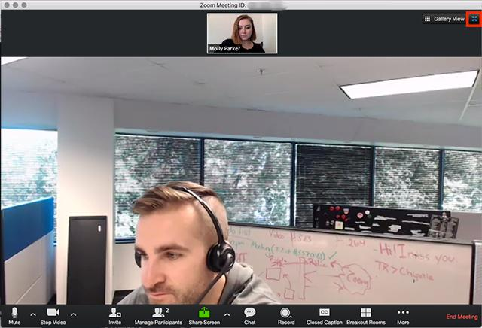
Active Speaker
Active speaker is the default video layout. It will switch the large video window between who is speaking. If it is a one-on-one meeting, it will display your video at the top, and the other participant's video below.
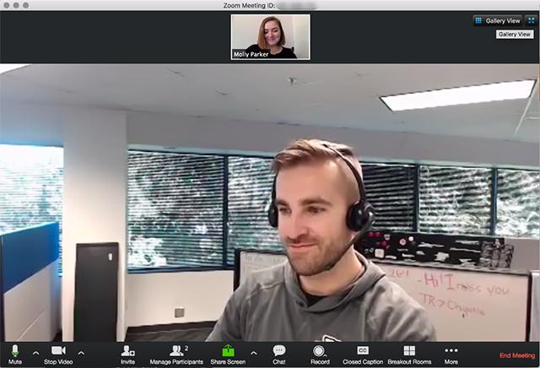

Gallery View
You can also select to view your video layout in Gallery View. When using Gallery View, you will be able to see up to 49 participants at a time.

